1. Create new public repository ‘freshersbatch-oct16’.

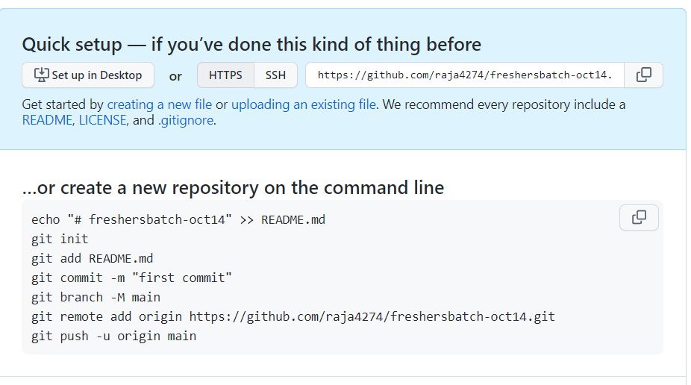

1. Commit & push any sample file to this repository under ‘Assignments’ directory.

